Academic Year: 2025-26 | Year: Second Year | Semester: II
PRN No.: 1012411011 | Name: Riddhee Kulkarni
Subject: Python Programming
Assignment No.: 8
Date: 05/01/2026

Lab Assignment: 08
Aim:
To write a Python program to check whether the user input is a number or a character.

Objective:
To identify whether the input entered by the user is a number or a single character.

Theory:
In Python, input is taken as a string.
- isdigit() checks if the input contains only digits
- isalpha() checks if the input contains only alphabets
- len() ensures the input is a single character

Algorithm:
- Start
- Read input from user
- If input is digit, print number
- Else if input is a single alphabet, print character
- Else print invalid input
- Stop

Pseudo Code:
START
READ value
IF value is digit
PRINT "Number"
ELSE IF value is alphabet AND length = 1
PRINT "Character"
ELSE
PRINT "Invalid input"
END IF
STOP

Code:
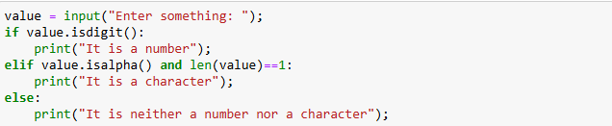

Output:
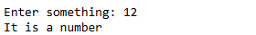
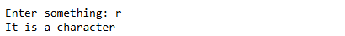

Conclusion:
The program correctly identifies whether the input is a number or a character using string functions.

